**SMART PUBLIC RESTROOMS**

**Sensors**:

* IR Sensors
* Occupancy Sensors
* Proximity Sensors
* Water flow sensors
* Motion Sensors
* Air Quality Sensors
* Temperature Sensors

**Datasets:**

Usage Data: Collect data on restroom usage, including the number of visitors, peak usage times, and average visit duration. This can help in optimizing cleaning schedules and resource allocation

Environmental Data: Gather data on temperature, humidity, and air quality within the restroom. This can be used to control heating, ventilation, and air conditioning (HVAC) systems for comfort and energy efficiency

Occupancy Sensing Data: Implement occupancy sensors to detect when restroom stalls are in use. This data helps in providing real-time information about stall availability and can be useful for crowd management.

Toilet Paper and Soap Dispenser Data: Install sensors on toilet paper and soap dispensers to monitor usage and refill requirements. This helps in efficient maintenance and avoids running out of essential supplies.

Cleaning and Maintenance Records: Keep a digital record of cleaning and maintenance activities, including when cleaning was last performed, what products were used, and any issues that were resolved

Feedback and Ratings: Allow users to provide feedback on the cleanliness and functionality of the restroom. Analyze this data to improve the overall restroom experience.

Water Usage Data: Monitor water usage in sinks and flushes to identify water-saving opportunities and detect leaks

Energy Consumption Data: Track energy consumption of lighting, HVAC, and other electrical systems to optimize energy usage.

Security Camera Footage: Install security cameras to monitor security and safety within the restroom area. Ensure privacy and data protection measures are in place.

User Behavior Analytics: Analyze user behavior, such as traffic flow within the restroom and user preferences, to optimize restroom design and resource allocation.

Inventory and Supplier Data: Keep track of inventory levels for restroom supplies (toilet paper, soap, etc.) and establish data connections with suppliers for automated restocking

Local Events and Calendar Data: Incorporate local events and public calendar data to predict rooms.

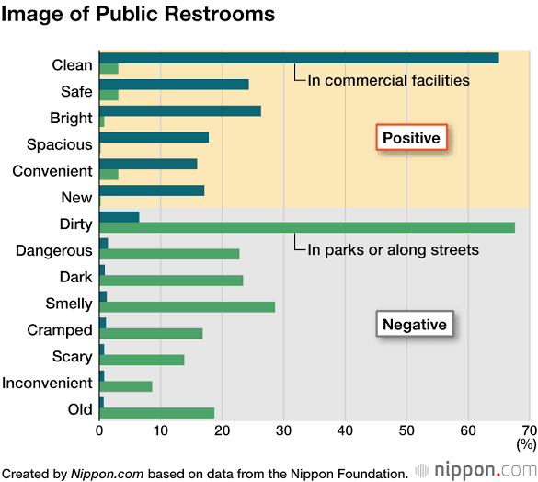

**MODEL RESULT:**

Automated Cleaning: Implement sensors and robotics to monitor restroom cleanliness and initiate cleaning when needed.

Occupancy Monitoring: Use occupancy sensors to track restroom usage and display real-time occupancy information for users.

Water and Energy Efficiency: Incorporate low-flow fixtures and energy-efficient lighting to reduce resource consumption.

Touchless Fixtures: Install touchless faucets, soap dispensers, and flush systems to minimize germ transmission.

Smart Maintenance: Implement predictive maintenance systems to monitor restroom equipment and ensure timely repairs.

User Feedback: Collect feedback through mobile apps or kiosks to improve restroom conditions and service.

Accessibility Features: Ensure ADA compliance with features like grab bars, accessible sinks, and changing stations.

Hygiene Stations: Offer hand sanitizing stations and hygiene supplies within the restroom.

Security: Use security cameras and alarms for user safety.

Real-time Updates: Enable users to check restroom availability and conditions via a mobile app or website.

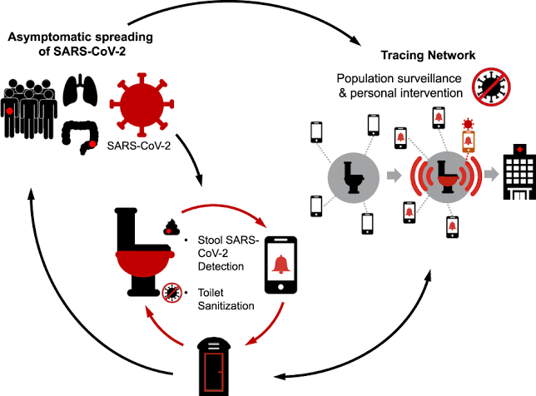

A system image is a comprehensive and exact duplicate of an entire computer's operating system, including the operating system itself, system files, installed applications, user data, and system configurations.

**TABULATION:**

In this example, we have various parameters and their corresponding readings. These readings represent data collected from different sensors or measurements in a given environment or system.

